**NASA Solutions Mechanism Guide installation instructions Draft 2, 07/29/2014**

Note that these instructions do NOT include endpoint protection or Manage Engine software.

**Application Technologies**

* Windows Server 2008 or 2012
* IIS
* IISnode <https://github.com/tjanczuk/iisnode>
* Node.js <http://nodejs.org/>
* Google Chrome
* Postman extension to Chrome (requires free Google user ID)
* Git (required only if checking in changes, not required to download code)
* MySQL 5.6 (requires free Oracle user ID)

**Application Setup**

**IIS**

We assume that IIS is already available on your server. If that is not the case, then follow the instructions at: <http://www.iis.net/learn/get-started/whats-new-in-iis-8/installing-iis-8-on-windows-server-2012>

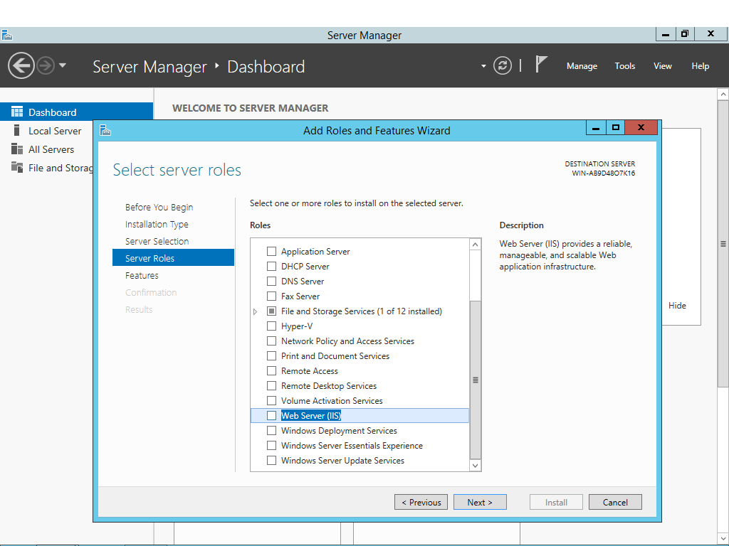

Control Panel > System and Security > Windows Update

**IIS configuration**

Setup configuration nasa-smg\web.config file if needed.

We have to be able to override configuration sections and to use URL authorization. Therefore we need to be sure that they are installed on IIS:

For Windows Server 2012

Run Server Manager. Select IIS from the left panel.

Add Roles and Features.

On the bottom of the Add Roles and Features Wizard, click Next button until you get to Server Roles.

Scroll down to “Web Server (IIS)” and expand that item.

Expand “Web Server” item.

Expand “Application Development” item.

Check (enable) the features. You can check all, or leave out CGI.

Click: "Security"

Check (enable) the URL Authorization feature.

Click "Next" until finished.

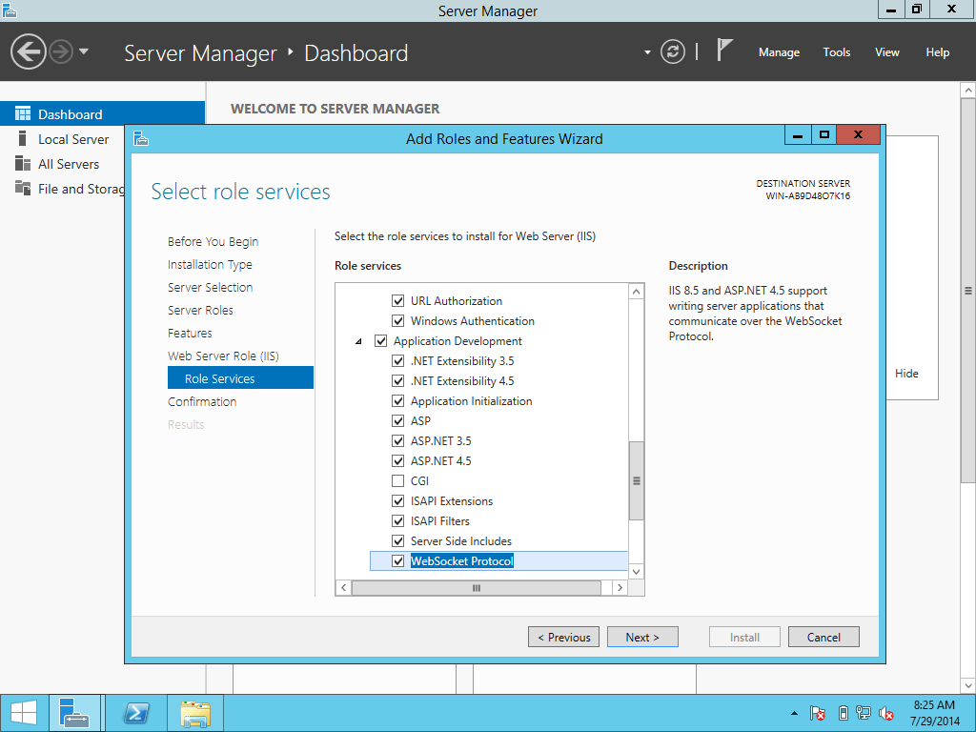

Specify an alternate source path for installation files, probably D:\Sources

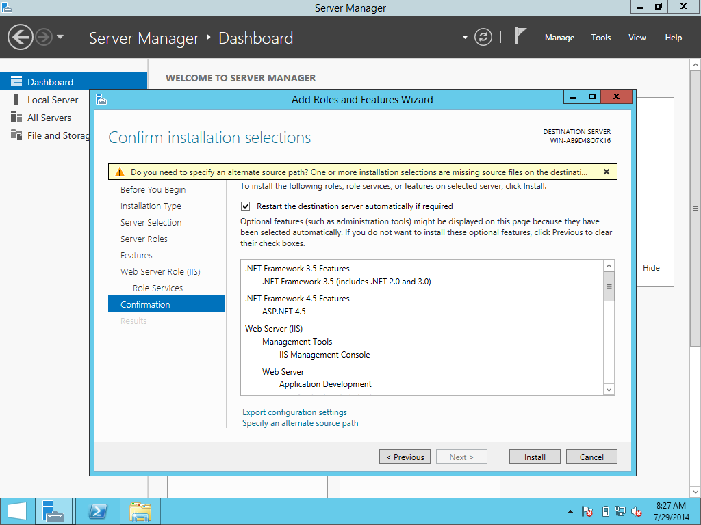

For Windows Server 2008

Go to the control panel

In the search box, enter "Turn windows features on or off".

The server manager will open.

Go to the roles section

Go to the Web Server (IIS) section

Look for the Role Services subsection

Click: "Application Development Features"

Install all the services (you can leave out CGI).

Click: "Security"

Install the URL Authorization feature.

Install URL rewrite module

<http://www.iis.net/downloads/microsoft/url-rewrite>

**Install Google Chrome**

This is necessary for Postman. You will need a (free) Google ID for the next step, so if you don’t have one, create it now.

**Install Postman extension for Chrome**

Get it from <http://getpostman.com>

You will need a (free) Google ID to install Postman as a Google extension.

**IISNode**

Install latest version of iisnode from <https://github.com/tjanczuk/iisnode>. Follow their instructions to install iisnode. (Read the sections called “Prerequisites for using” and “Installing for IIS*”) The default location is C:\Program Files\iisnode

From the C:\Program Files\iisnode folder, run setupsamples.bat

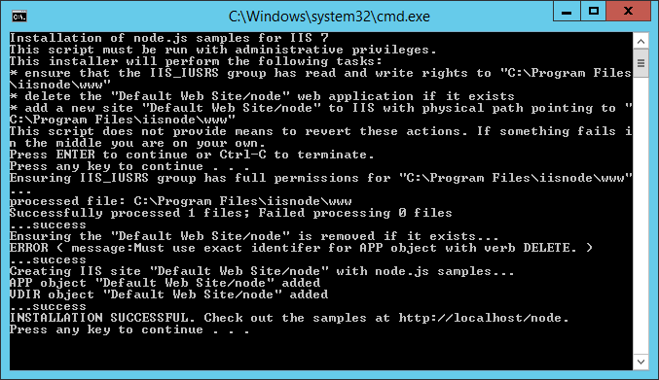

Test at <http://localhost/node>

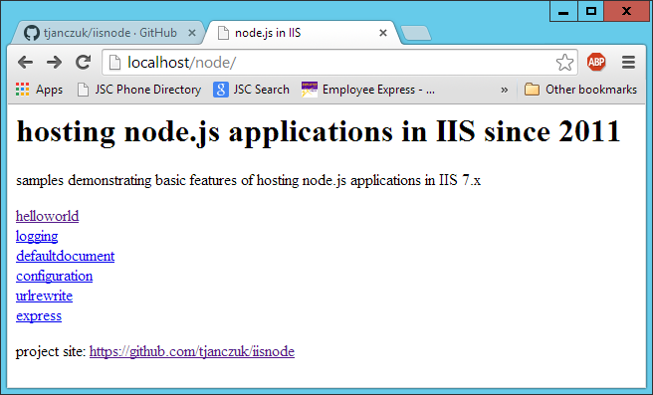

Make sure the helloworld and hello.js endpoint are working.

Edit the system configuration file

Open the applicationHost.config file, located here: %windir%\system32\inetsrv\config\applicationHost.config

Edit the "handlers" section.

Change this line: <section name="handlers" overrideModeDefault="Deny" />

To: <section name="handlers" overrideModeDefault="Allow" />

Edit the "authentication" section group

Change this line: <section name="anonymousAuthentication" overrideModeDefault="Deny" />

To: <section name="anonymousAuthentication" overrideModeDefault="Allow" />

Change this line: <section name="windowsAuthentication" overrideModeDefault="Deny" />

To: <section name="windowsAuthentication" overrideModeDefault="Allow" />

Save the file and exit.

**Install nodejs**

Get latest from <http://nodejs.org/> . (Tested with v0.10.29.) Default destination folder is C:\Program Files\nodejs

**SMG Code Deployment Instructions**

**Github Code**

If you will be checking in code from this computer, install the Github client and checkout the code from this repository under 'www' folder of the iisnode installation (i.e. C: \Program Files\iisnode\www\nasa-smg). (Or, instead of installing the Github client, download the Zip file from Github and unzip it in that folder.)

On terminal (cmd), navigate to the code folder and run “npm install”

cd \Program Files\iisnode\www\nasa-smg

npm install

**Restart IIS from the IIS manager**

Press (Windows)-R and run inetmgr

Install the SMG application on IIS. In the IIS Manager, right click on “Sites” and click “Add Website”

Set name to smg, choose physical path and set port to 5000 (you can use any port you want)

Click Connect As… button and enter Administrator userid and password.

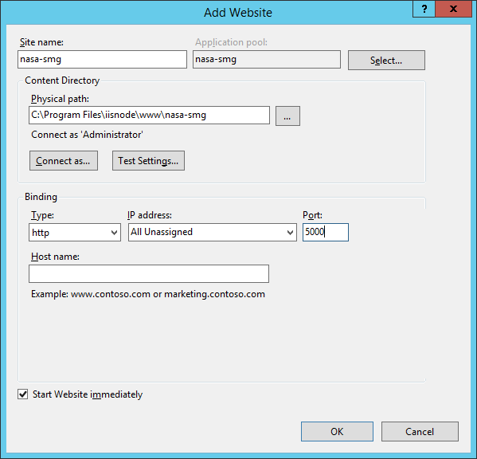

From the IIS Manager, select IIS and restart it.

**Database Setup**

Install MySQL from <http://dev.mysql.com/downloads/>

You will need a (free) Oracle ID. Install “MySQL on Windows,” choosing only the Server configuration. Make the user “root” with password “aaaa”, port 3306. (MySQL insists on at least 4 characters in the password. We will change it to a blank password later.)

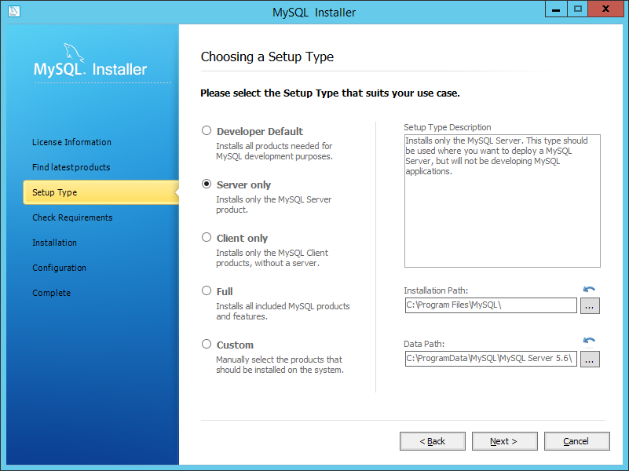

Start a command prompt, cmd

Change to the MySQL bin directory

cd \Program Files\MySql\MySql Server 5.6\bin

Change the MySQL password to blank.

Mysqladmin –uroot –paaaa password

(Then press enter twice.)

Using that same cmd command shell, we will create an empty database in MySql server. On a Windows server; use nasasmg [with no dash] instead of nasa-smg.

mysql -uroot

mysql> create database nasasmg;

mysql> exit;

**Configurations**

Configuration is done at the web.config file. If you open it, there will be a section called “appSettings”. In that section you can find the following options:

DB_HOST : The host for MySQL server. (i.e. localhost)

DB_NAME : The MySQL database name. (i.e. nasasmg or nasa-smg)

DB_PORT : The port for MySQL server. (default 3306)

DB_USER : The username to login to MySQL. (default root)

DB_PASSWORD : The password to mysql server. (default empty password )

RESET_TABLES : The flag if recreate database. It will drop and create again all tables. Test data is not inserted. Tables will be reset each time you run node app. false

DOWNLOADS_DIR : The path to directory where files are downloaded. default to /downloads.

In the same folder, change env_sample.bat file with the same database name and password.

Application is restarted every time you edit web.config.

**Install SMG Tables**

Start a command prompt, cmd

Change to the nasa-smg directory

cd \Program Files\iisnode\www\nasa-smg

Edit batch file “env_sample.bat” to set the correct database name and password.

Run that batch file to set up the environment variables needed in the next step.

Run the script to create the database itself:

..\..\..\nodejs\node.exe resetDb.js

Run the script to install the tables:

..\..\..\nodejs\node.exe generateRealFrontend.js

**Testing**

You can check SMG now <http://localhost:5000/>

To access SMG admin portal use: <http://localhost:5000/admin/smg>